* Java class includes instance variables and methods.
* Class is a template for an object, defines the shape and behaviour of an object.
* Object is an instance of a class.

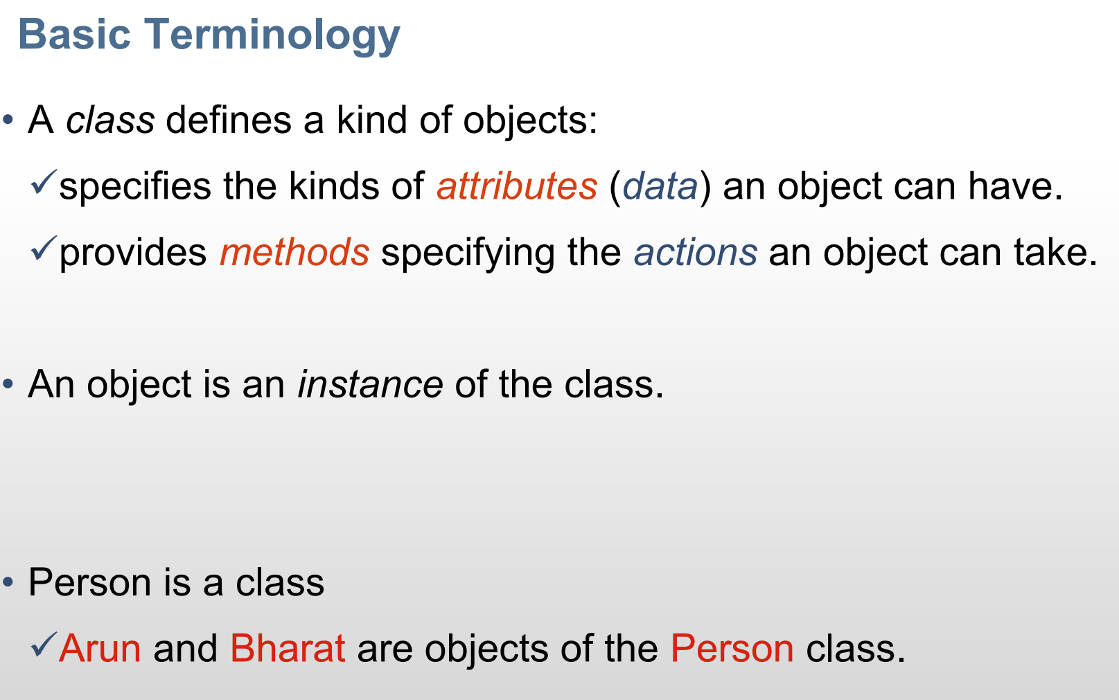

1. syntax:

class Class_name

{

Instance variables(optional);

Constructors(optional);

Various methods(optional);

Main method(optional);

/*one of the four things is necessary otherwise its useless to create a list in the first place*/

}

1. Declaration for creating an object :

Class_name object_name=new Classname(//parameters in case of parameterized constructors);

🡪programming examples aside.

CONSTRUCTORS

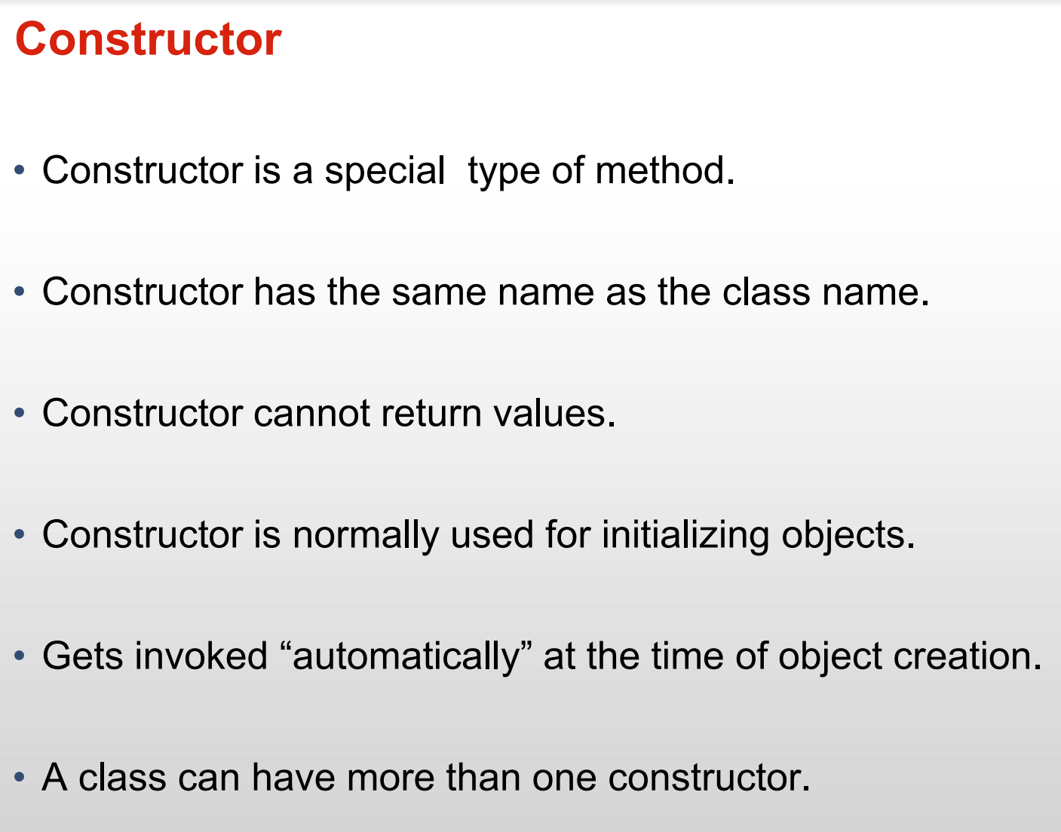

PARAMETERIZED AND NON-PARAMETERIZED CONSTRUCTORS🡪explain later…

THIS KEYWORD:

🡪done to differentiate between two variables with the same names.

🡪example:

Class Box

{

double height, width, depth;

Box(double width,double height,double depth)

{

this. width=width;

this. height=height;

this. depth=depth;

}

}

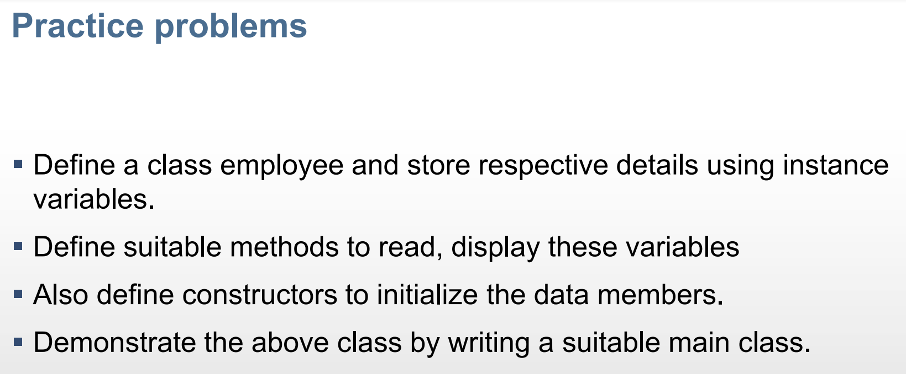

OVERLOADING METHODS:

🡪having two or more methods with the same function name but different signatures(arguments/formal parameters) is called method/function overloading.

🡪example: methods for the calculation of area of rectangle, circle, triangle.

🡪Example in class 11th textbook

CONSTRUCTOR OVERLOADING:

🡪having two or more constructors with the same (class)name but different signatures(parameters) is called constructor-overloading.

🡪example- different parameters for initializing different variables for different figures.

🡪elaborate later.

USING OBJECT AS A PARAMETER:

🡪example:

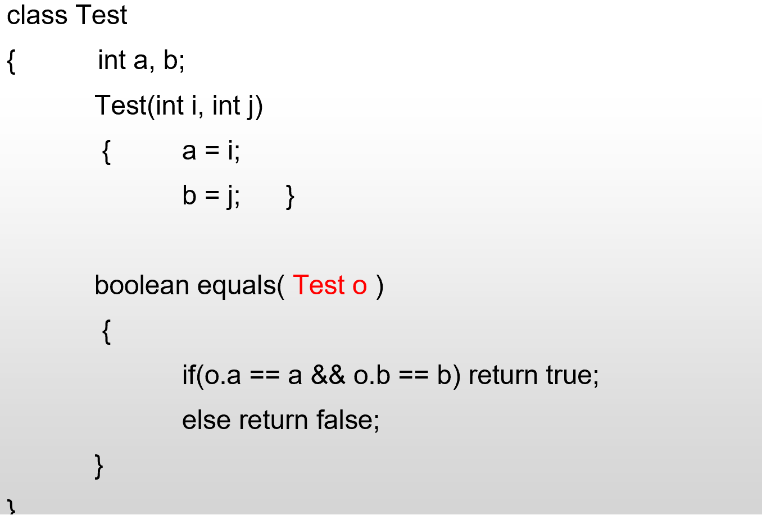

RECURSION:

USE OF ‘STATIC’ KEYWORD:

